 | ALL SAINTS’ COLLEGE  Ewing Avenue, Bull Creek, Western Australia
 | HUMAN BIOLOGY

Year 11 2005 - Semester I Examination - Question/Answer Booklet
C.C. STUDENT NUMBER - In figures 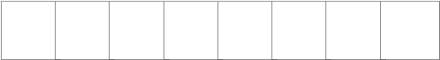

TIME ALLOWED FOR THIS PAPER
Reading time before commencing work: Ten minutes
Working time for paper: Two hours thirty minutes

MATERIAL REQUIRED/RECOMMENDED FOR THIS PAPER
TO BE PROVIDED BY THE SUPERVISOR
This Question/Answer Booklet
Standard Answer Booklet
Multiple Choice Answer Sheet

TO BE PROVIDED BY THE CANDIDATE
Standard Items: Pens, pencils, eraser and ruler.
Special Items: A 2B, B or HB pencil for the separate Multiple Choice Answer Sheet and calculators satisfying the conditions set by the Curriculum Council.

INSTRUCTIONS TO CANDIDATES

See page 2.

IMPORTANT NOTE TO CANDIDATES
No other items may be taken into the examination room.
It is your responsibility to ensure that you do not have any unauthorised notes or other items of a non-personal nature in the examination room. If you have any unauthorised material with you hand it to the supervisor BEFORE reading any further.

SEE PAGE 2
STRUCTURE OF THIS PAPER

Part | No. of questions  available | No. of questions to be attempted | Marks available
I Multiple Choice  II Diagram and Short Answer questions  III Extended answer questions: | 40  6  2 | ALL  ALL  1 | 80  80  20

Total Marks = 180 → 100%

INSTRUCTIONS TO CANDIDATES

PART I Should be answered on the separate Multiple Choice Answer Sheet. Use a 2B, B or HB pencil, NOT A BALL POINT OR INK PEN.

PART II Should be answered in this Question/Answer Booklet. Write your answers in the spaces provided, using a blue or black ballpoint or ink pen. Draw any diagrams in pencil.

PART III Should be answered in the Standard Answer Booklet, using blue or black ballpoint or ink pen.

Make sure your Curriculum Council Student Number is on your Multiple Choice Answer Sheet, this Question/Answer Booklet and the Extended Answer Booklet.

PART I : Multiple Choice (80 Marks)

Suggested time : 50 minutes.
Mark your answers to Questions 1 – 40 on the SEPARATE MULTIPLE CHOICE ANSWER SHEET, using a 2B, B or HB pencil. If you make an error follow the instructions given to you on your answer sheet.

1. The membrane which covers the lungs and lines the thoracic cavity is the
A periosteum.
B pleura.
C peritoneum.
D pericardium.

2. The function of the membrane in the question above is to
A hold the lungs in their correct position in the cavity.
B help increase the volume of the cavity.
C secrete a fluid enabling the lungs to slide on the thoracic wall.
D help the diaphragm increase or decrease the volume of the thorax.

3. A scientific experiment should have a control group. The control group is needed to
A ensure only one variable is tested at a time.
B serve as a basis for comparison.
C make the experiment more accurate.
D prevent mistakes being made.

4. The main effect of the presence of intestinal villi is to
A move food along the intestine.
B surround and digest food particles.
C greatly increase the area over which absorption of food can occur.
D act as valves to prevent a flow of food in the wrong direction.

5. Synovial joints are encapsulated and strengthened by
A tough cords called tendons.
B a smooth, tough layer of articular cartilage.
C a layer of epithelial tissue called the synovial membrane.
D strong bands of connective tissue called ligaments.

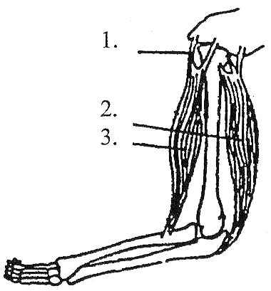
6. The part labelled 1 in the diagram on the right is the
A tendon of muscle labelled 3.
B insertion of muscle labelled 3.
C origin of muscle labelled 3.
D ligament of muscle labelled 3.

Questions 7 & 8 refer to the following diagram.
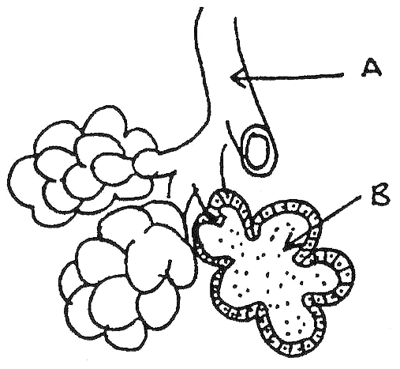
7. Structure B is called
A a bronchus.
B an aerolar sac.
C an alveolar sac.
D a bronchiole.

8. The shape of B is important because
A it provides a large surface area for diffusion.
B it allows air to enter the lungs easily.
C it contains more cells for respiration.
D it makes it easy to remove dust particles from the lungs.

9. If body temperature decreases from 37°C to 32°C, enzyme activity will most likely
A remain the same.
B increase.
C decrease.
D cease.
10. Consider the following list of characteristics :
I reduced sense of smell.
II hindlimbs shorter than forelimbs.
III presence of body hair.
IV opposable digit on both limbs.
V forelimbs shorter than hindlimbs.
VI opposable thumb only.
VII presence of nails instead of claws.
VIII presence of forward directed eyes.
IX teeth of four distinct types.
It would be reasonable to state that the
A presence of II, III and IX is sufficient evidence to permit classification of a mammal as a member of the Order of Primates.
B presence of I, III, VII and VIII is sufficient evidence for classification of a mammal as a member of Family Hominidae.
C members of Family Pongidae possess II, IV and IX.
D members of Family Hominidae possess IV, V and IX.

11. Old World monkeys and New World monkeys differ in many anatomical and behavioural features. Which of the following statements is correct?
A Old World monkeys have a well developed prehensile tail, New World monkeys tails are enormously variable but none are prehensile.
B Old World monkeys have thick calloused skin called ischial callosities on which they sit while feeding or sleeping in trees; New World monkeys have no such feature.
C Old World monkeys live primarily in forest habitats; New World monkeys live in diverse habitats ranging from savannahs and semi-arid deserts to rainforest and high mountains.
D Old World monkeys have widely spaced nostrils that open upwards; New World monkeys have nostrils that are close together and open downwards.

12. Lactic acid accumulates in the muscle tissue when muscles are
A demanding more oxygen than can be supplied by the blood.
B relaxing and therefore not demanding oxygen.
C contracting and therefore are requiring more oxygen.
D supplied with sufficient oxygen.

13. The following four statements are about the cardiac cycle.
1. Atrial systole is the phase of active contraction of the atria.
2. Ventricular diastole is the period during which filling of the ventricles occurs.
3. Blood enters the aorta and the pulmonary arteries during ventricular systole.
4. Blood enters the right atrium from the pulmonary veins during atrial diastole.

Which group of the above statements is correct?
A 1 and 2 only are correct.
B 1, 2 and 3 only are correct.
C 2, 3 and 4 only are correct.
D All are correct.

14. Striated muscle fibres are noted for their ability to contract powerfully and quickly. However, contraction cannot be maintained for long periods. Therefore striated muscles would be found in the
A pyloric sphincter muscle.
B ventricle of the heart.
C biceps muscle.
D walls of the arteries.
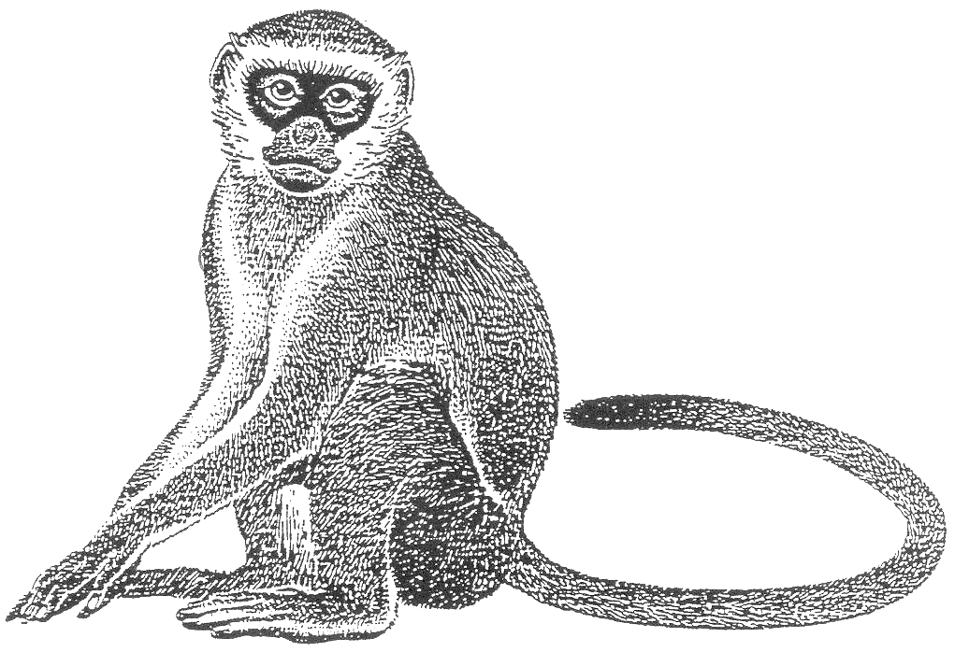

15. The common name for this primate is Vervet monkey. Its scientific name is

A Cercopithecus Neglectus
B cercopithecus neglectus.
C cercopithecus Neglectus.
D Cercopithecus neglectus.

16. Which substance would turn a blue-black colour when treated with a few drops of iodine solution?
A Table salt.
B White bread.
C Table sugar.
D Powdered milk

17. Which of the following statements about circulation through the heart is incorrect?
A The pulmonary arteries carry deoxygenated blood to the lungs.
B The chambers on the right hand side of the heart contain oxygenated blood.
C The semilunar valves prevent blood flowing backwards into the ventricles.
D The pulmonary veins delivers oxygenated blood to the left atrium.

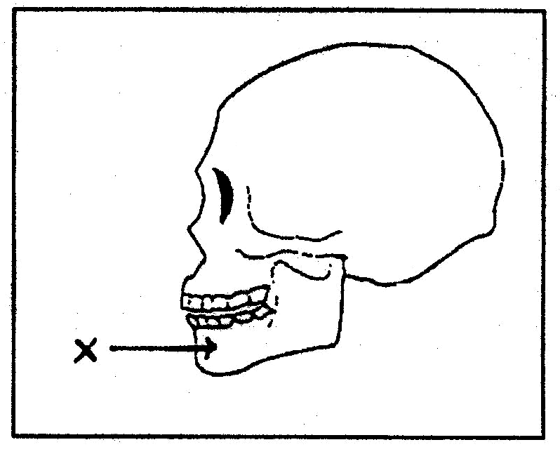
18. The bone marked X is the
A occipital.
B maxilla.
C mandible.
D parietal.

19. Humans are classified in the phylum
A Hominidea.
B Vertebrata.
C Chordata.
D Mammalia.

20. Which chemical substance is most easily digested and then used as an energy source in the human body?
A Lipids.
B Proteins.
C Vitamins.
D Carbohydrates.

21. Hypertension is often caused by
A excessive salt intake.
B excessive protein intake.
C Vitamin D.
D Vitamin C.
The following three questions 22 – 24 refer to the graph below.

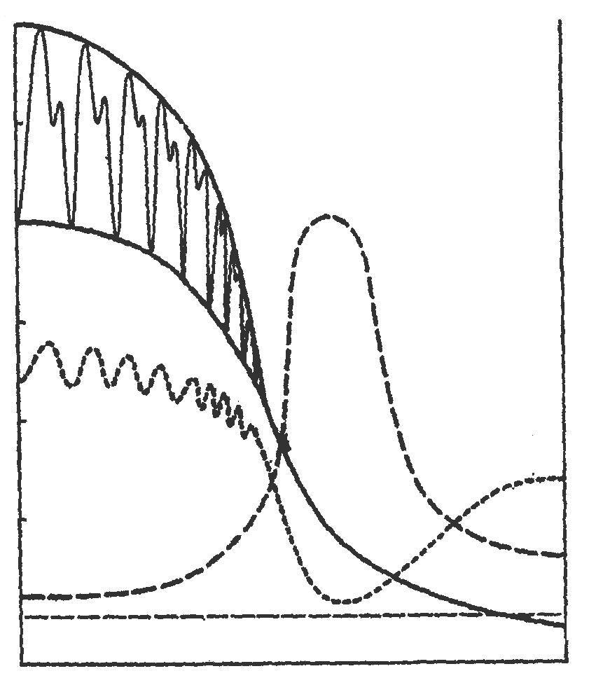
Different Measures of
120 systolic pressure Vessel Physiology

Pulse
Pressure 100

80
diastolic
pressure
60

mm Hg
40 Velocity

20 cross-section area

−
0 0
+
-10
Aorta Arteries Arterioles Capillaries Veins Vena Cave

22. Which of the blood vessels have the greatest total surface area and the slowest blood flow?
A Arteries.
B Capillaries.
C Arterioles.
D Veins.

23. Systolic pressure is lowest in the
A veins.
B capillaries.
C arteries.
D venules.

24. The exchange of substances between cells and the circulatory system would take place where the
A velocity of blood was fastest and the surface area least.
B velocity of blood was slowest and the surface area most.
C systolic pressure was minimal and in the tissues of the lungs.
D surface area was least and velocity of the blood slowest.

25. Valves occur in the circulatory system in the
A heart and arteries.
B capillaries, vein, arteries.
C heart and veins.
D capillaries and heart.

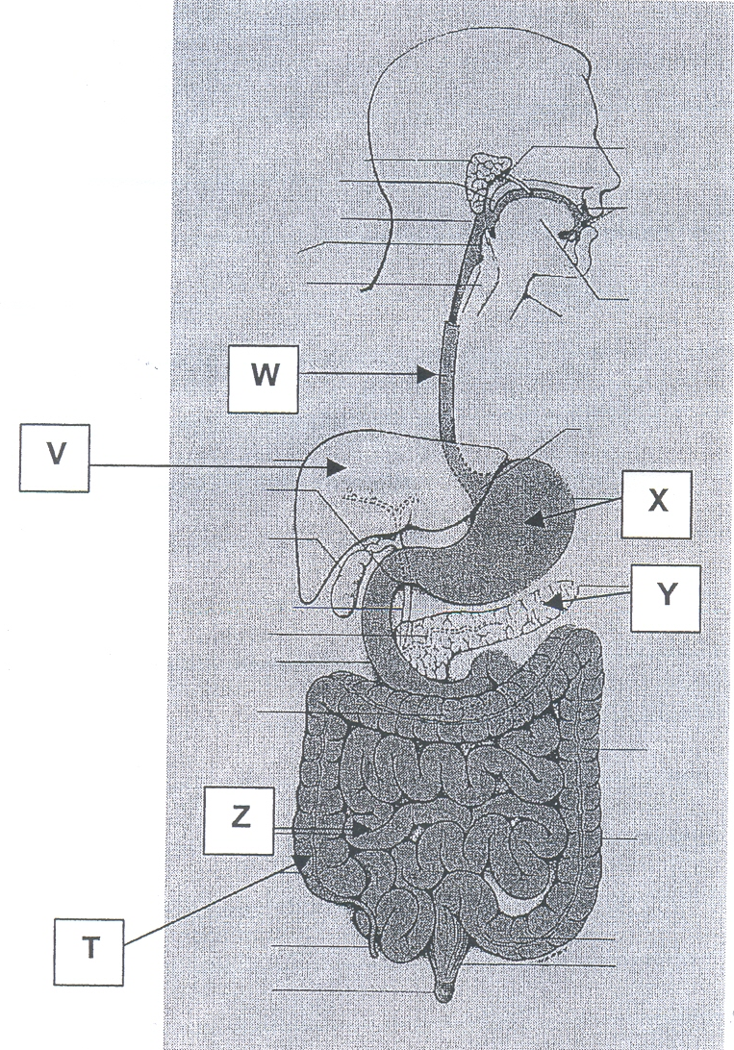
Use the following diagram to answer question 26.

26. Which group of labels identifies three structures that perform peristalsis?

A T, V and Z.
B T, W and Z.
C V, W and X.
D V, X and Y.

27. From the list below, select the three essential requirements for efficient exchange of gases through the respiratory membranes.

I moistness
II dryness
III small surface area
IV large surface area
V many cells thick
VI one cell thick.

A I, IV, V.
B II, III, VI.
C I, IV, VI.
D II, IV, V.

28. An enzyme is a/an
A chemical messenger.
B carbohydrate.
C organic catalyst.
D small molecule.

29. Which of the following statements about stereoscopic vision is incorrect?
A Forward facing eyes have a greater degree of overlap between the field of each eye.
B Eyes more to the side of a snout have a greater total field of view.
C Forward facing eyes make judging distances easier.
D Forward facing eyes allows them to see a greater distance.

30. The digestion of protein, carbohydrate and fat begins first in
 | Protein | Carbohydrate | Fat
A | duodenum | mouth cavity | stomach
B | stomach | ileum | duodenum
C | mouth cavity | stomach | ileum
D | stomach | mouth cavity | duodenum

Questions 31 and 32 refer to the following information.
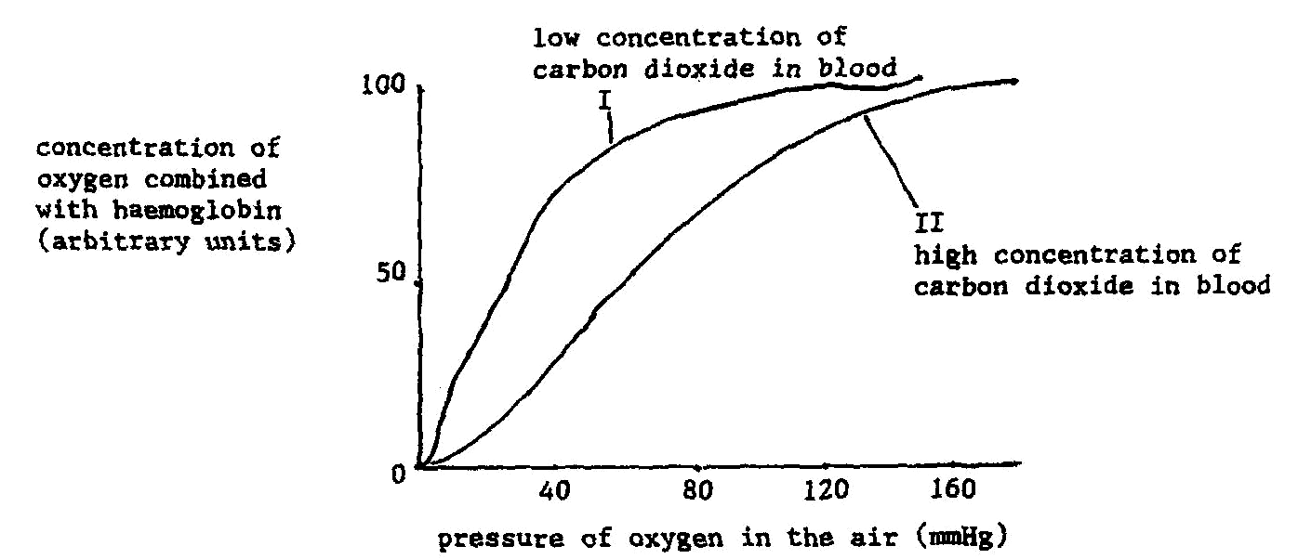
The diagram shows variations in the concentration of oxygen combined with haemoglobin in the blood with the pressure of oxygen in the air for two different concentrations of carbon dioxide.

31. At an oxygen pressure of 30 mmHg in the air, the concentration of oxygen combined with haemoglobin in Graph I was compared to that in Graph II. The amount of oxygen combined with haemoglobin in Graph I has
A increased.
B remained the same.
C decreased.
D decreased and then increased.

32. Symptoms resulting from lack of oxygen become evident when the oxygen pressure falls to 60 mmHg from normal (120 mmHg). These symptoms would be
A less obvious with a low concentration of carbon dioxide in the blood.
B less obvious with a high concentration of carbon dioxide in the blood.
C unaffected by variations in the concentration of carbon dioxide in the blood.
D characterised by a lowering of the breathing rate.

33. People who are strict vegetarians should select their food carefully in order to prevent a deficiency in which group of substances?
A Essential amino acids.
B Complex carbohydrates.
C Vitamins.
D Minerals.

34. Which of the following drawings represents a lumbar vertebra (A, B, C, D)?

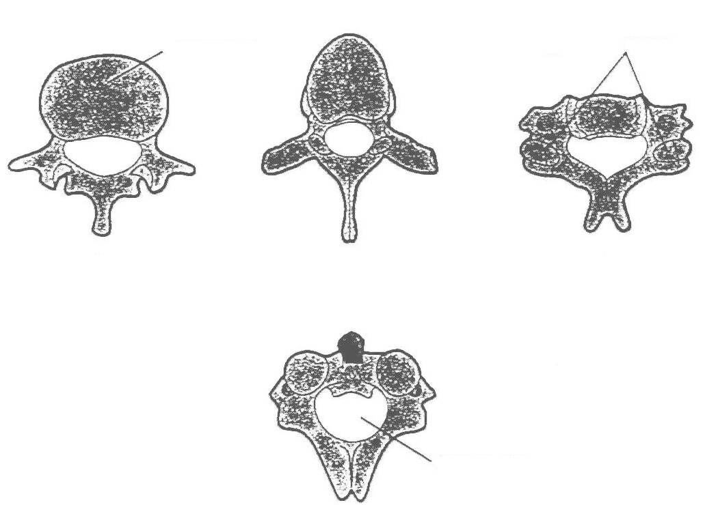
Centrum Articulating Surface

A B C

Spinal Foramen

D

35. Atherosclerosis is
A high blood pressure in the arteries.
B a medical term for a "stroke".
C hardening of the arteries.
D a blood-shot eye.

36. When a person is exposed to changes in the composition of their normal gaseous envirnoment, their breathing rate alters.

The following results were obtained after testing a randomly-sampled group of 100 students.

Test | Gas Composition |  |  |  |  |  | Breaths/Minute
Test |  |  |  |  |  |  | 1st | 2nd | 3rd | 4th | 5th
Test 1 | 90% | O₂ | 0⋅08% | CO₂ | 10% | N₂ | 16 | 15 | 13 | 14 | 16
Test 2 | 90% | O₂ | 10% | CO₂ |  |  | 16 | 17 | 19 | 23 | 28
Test 3 | 20% | O₂ | 0⋅08% | CO₂ | 80% | N₂ | 16 | 15 | 15 | 16 | 15

A satisfactory conclusion drawn from these results would be that
A increase in CO content causes increases in breathing rate.
B increase in O₂ above 20% causes increases in breathing rate.
C pure O₂ will not support life.
D nitrogen concentration has little effect on breathing rate.
37. Rickets is caused by a deficiency in
A Vitamin B.
B Iron.
C Calcium.
D Vitamin C.

38. What form of locomotion best describes the movement of Siamang (giant gibbon)?
A Quadrapedal branch runner and jumper.
B Partial Brachiator.
C Brachiator.
D Quadrupedal ground runner and tree climber.

39. When using a sphygmomanometer to measure the blood pressure of a healthy young adult
A the systolic pressure would be approximately 75 mmHg.
B the systolic pressure would be lower than the diastolic pressure.
C the pressure of the oxygenated blood would be called systolic and that of the deoxygenated blood would be diastolic.
D the systolic pressure is that at which the sounds through the stethoscope first become audible.

40. Which of the following statements is in agreement with scientific methodology?
A If a hypothesis is properly constructed then tests and observations will support it.
B If a hypothesis is properly constructed then it will lead to a testable prediction.
C If observations are accurate, they will support a hypothesis.
D If experiments are properly controlled, they will generate a testable hypothesis.

END OF PART I
PART II : Diagram and Short Answer (80 Marks)
Suggested time : 70 Minutes
Write answers to ALL questions on the lines after each question or in the spaces provided.
Write your answers in blue or black ballpoint or ink pen. Draw diagrams in pencil.

41. (15 Marks)
(a) The following question refers to the diagram below.
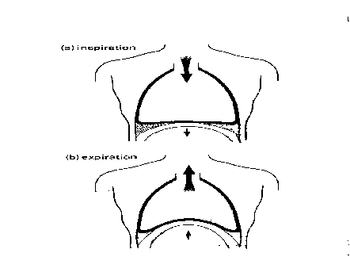
Fill in the table to show what events take place to cause the changes in the thoracic cavity volume and explain how these changes result in inspiration and expiration.
(8m)

Breathing | Events causing thoracic cavity volume changes | Explanation of how this results in inspiration/expiration
Inspiration

Expiration

41. (ctd)
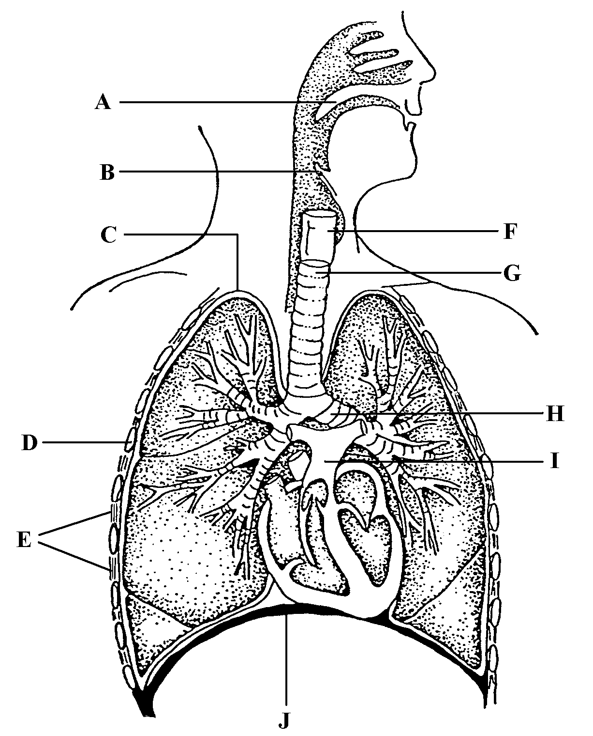

(b) Study the diagram above.
(i) Label the parts
B G
C H
E J
(3m)

(ii) Name the structures in which you expect to find ciliated cells? (1m)

(iii) What would be the function of these ciliated cells? (1m)

41. (c) In mouth to mouth resuscitation you are required to carry out a number of steps prior to and during the process. Some of these steps are listed below out of sequence.

1. Ascertain whether there is any pulse, and begin resuscitation.
2. Begin breathing - 2 quick breaths then …
3. Check to see if there is any breathing or circulation.
4. Check dangers - tie hair back, turn off power etc.
5. Check and clear airway of any obstructions.

(i) Write down the correct order of steps one should follow to carry out resuscitation of someone.
(1m)

(ii) Assuming you have successfully restored breathing to a person, what should be done after the person begins to breathe independently, and why?
(1m)

42. (15 Mark)
The following diagram shows how certain vessels of the circulatory system associate with muscle cells.
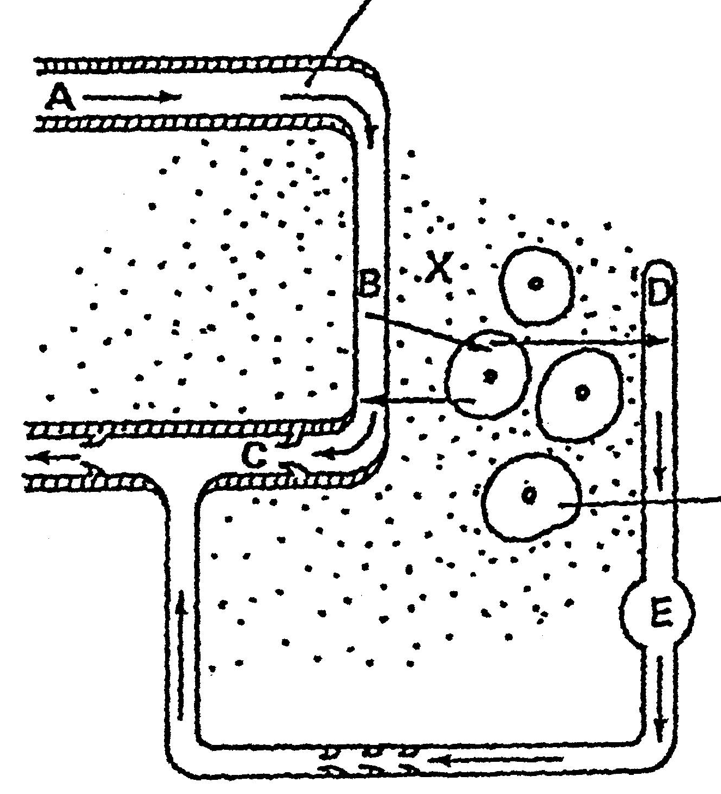
Flow of blood

Body cell

(a) Name blood vessels
A
B
C (3m)
42. (b) Describe two ways by which materials pass from space B to space X.
1.
2.
(4m)

(c) Name the fluid in space X.
Give an example of two substances that
(i) move from B into X
(ii) move from X into B
What is one thing that does not leave B?
(4m)

(d) When a person is not well, blood samples are often taken and a blood cell count is made. The diagram below shows blood cells as seen under a microscope.
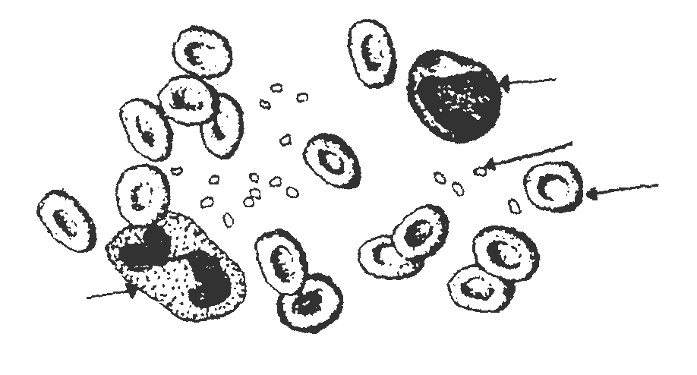

C

B

A

C

For the cells A, B and C, name each cell type and describe the physiological problems a person may have if they had lower than normal numbers of that cell type.
(4m)

 | Cell Type | Physiological Problem
A

B

C

43. (10 Marks)
The table below shows what happened to the average systolic blood pressure of two groups of people. The people in Group A smoked 2 cigarettes (containing nicotine) per day, while Group B received no cigarettes.

Day | Systolic Blood Pressure (mm of Mercury)
Day | Group A (Cigarettes) | Group B (No Cigarettes)
1 | 116 | 118
3 | 119 | 116
5 | 125 | 118
9 | 130 | 120
13 | 134 | 120
15 | 132 | 122
19 | 135 | 120
22 | 133 | 118

(a) What hypothesis was being tested? (1m)

(b) Name the independent variable. __________________________________ (½m)

(c) Name the dependent variable. __________________________________ (½m)

(d) Name 4 variables that would have to be controlled. (2m)

(e) Draw the graph of the table on the graph paper below. (3m)

43. (ctd)
(f) Explain why two groups of people were used rather than just two individual people.
(2m)

(g) What should the researcher do to ensure these results are reliable? (1m)

44. (10 Marks)
(a) The diagrams show the arrangement of the lower leg bones in a human (a) and a chimpanzee (b).
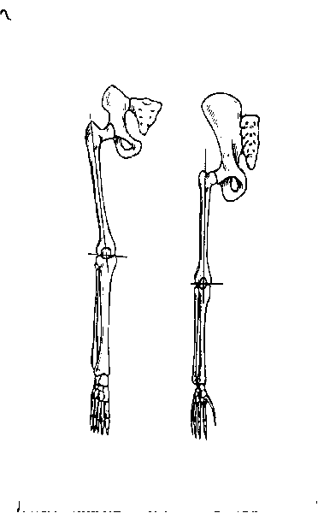 (a) (b)

(i) How does the difference in the arrangement of the femur and tibia affect the way they each walk?

Human :

Chimpanzee :

(4m)

44. (a) (ii) What are two other adaptations in the lower limb structure which aid in walking for humans?

1.

2.

(2m)

44. (iii) A primate fossil skull is discovered. What evidence would you look for to decide whether or not this organism would have been capable of sustained erect walking during its life?
(1m)

(b) List three characteristics that cause the Prosimians to be classified as the most primitive of the primates.
(3m)
1.
2.
3.

45. (15 Marks)
The diagram shows the bones and the main muscle groups of the leg which are used in standing and walking.
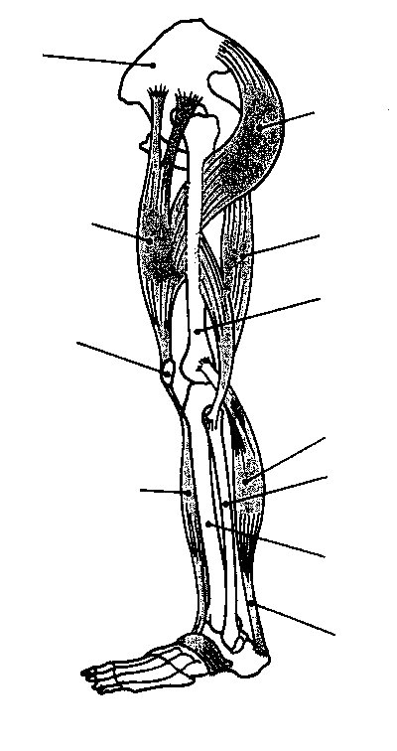
10

1

9
2

3
8

4
5
7

6

Y

(a) Name the numbered structures. (5m)
1. 6.
2. 7.
3. 8.
4. 9.
5. 10.

(b) Muscles 2 and 9 are antagonistic.
(i) Explain what this means. (1m)

(ii) Which joint do they move? (1m)

(iii) Explain their action in causing this joint to bend and straighten. (2m)

45. (c) What are the leg and foot doing in
(i) the support phase of walking? (No muscle detail required.)

(ii) the swing phase of walking? (No muscle detail required.)

(2m)

(d) Name structure Y and state its function in locomotion. (2m)

(e) Describe how the microscopic structure of the part labelled 3, provides the necessary strength to support the body.
(2m)

46. (15 Marks)
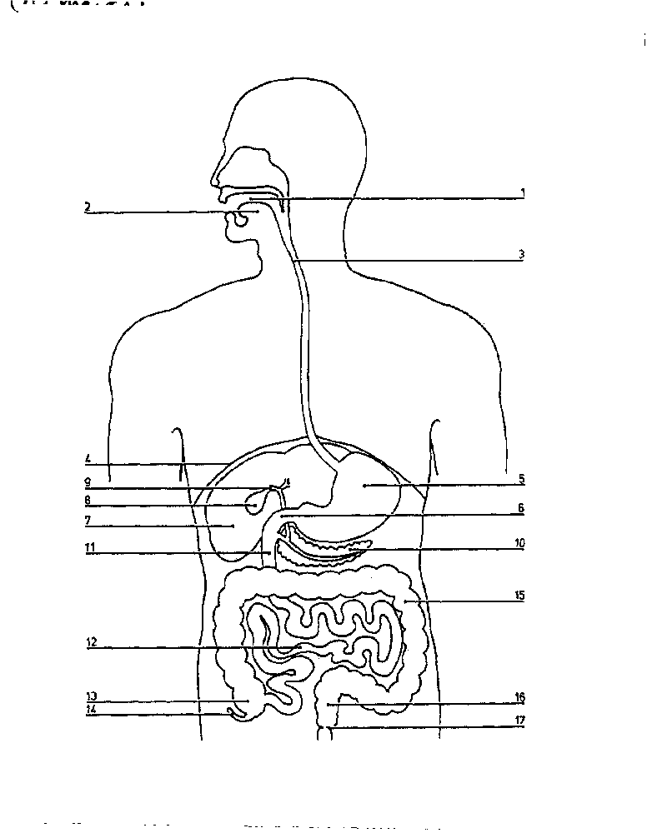 (a) The diagram shows the digestive system.

Complete the following table.
No. of Structure | Name of Structure | Function in Digestive System
 |  | Production of pancreatic juice containing enzymes.
3

 | Colon (descending)
8

 | Stomach
(7m)

46. (b) The graph below shows the effect of pH on activity level of three digestive enzymes.
(i) From the graph what conclusion can be made about the relationship between the action of the enzyme and pH value?
(1m)

(ii) Using the letters A, B and C, match the curves to the following enzymes : pancreatic protease, gastic protease and salivary amylase.
(2m)
A
B
C

(c) (i) Explain what is meant by a balanced diet? (2m)

46. (c) (ii) Describe the specific dietary needs of a teenager. (3m)

END OF PART II
PART III : Extended Answers (20 Marks)
Suggested time : 30 minutes.

Answer one question only. Illustrate your answer with diagrams where appropriate. Up to two marks may be deducted for poorly structured answers : that is, answers in point form or diagrams not explained in the text of your answers.

Remember to plan your answer and cross out your plan when you have finished using it.

DO NOT WRITE ANSWERS IN PENCIL.
Write your answers on the lined pages in your Separate Answer Booklet.
Answer either all of Question 47 or all of Question 48 – NOT BOTH.

47. (a) Explain why it is that, in the lungs, oxygen diffuses into the blood and carbon dioxide diffuses out of the blood, whereas in other body tissues oxygen diffuses out of the blood and carbon dioxide diffuses into the blood. Your answer should also include details of how oxygen and carbon dioxide are carried in the blood.

(10m)

(b) Decribe how the small intestine is structually suited to perform specific functions.
(10m)

O R

48. The human body has many joints where bones meet.

(a) For the three main types of joints, briefly outline how their structure suits their function in the body.
(3m)

(b) Synovial joints allow different degrees of movement. Use an example of each of the various types of synovial joints, to relate the movement each allows to its position and function in the body.
(10m)

(c) Use a named example from (b), to describe the structure and function of the main parts of a synovial joint.
(7m)

END OF EXAMINATION

